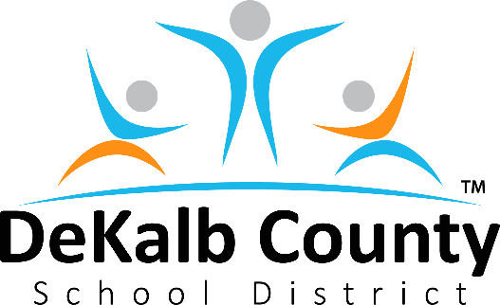
Mr. Marshall D. Orson, Board Chair
Mrs. Vickie B. Turner, Vice Chair
Mr. Stan O. Jester
Dr. Michael A. Erwin
Mrs. Allyson Gevertz
Mr. Diijon DaCosta
Dr. Joyce Morley

Mrs. Cheryl Watson-Harris, Superintendent

Dear DeKalb County Parents,

As the new school year approaches, we've received a lot of feedback and questions around the state of fall athletics. Many of you have children who have started preparations for the season, while also preparing for remote learning.

After careful consideration, I am writing today to regretfully inform you that the DeKalb County School District has decided to delay the 2020 fall athletic season. The district will continue conditioning through September while monitoring and revisiting its plan. Upon evaluating local health data and taking into consideration the feedback of all involved parties, we believe this is the best decision to protect the safety and well-being of our student-athletes and families in light of the COVID-19 pandemic. We will continue to monitor the data provided by health partners and will revisit to make a determination regarding fall sports at the end of September.

This was a difficult decision that followed months of evaluation. In June, our district allowed on-campus training with safety measures in place, including limiting the number of participants in pods, implementing temperature checks and social distancing guidelines, and encouraging face coverings.

Despite these precautions, we've seen an increase in COVID-19 positive cases among student athletes and athletic staff in recent weeks. Based on this, the latest data from the DeKalb County Board of Health and the input we received from parents, staff and other stakeholders, we reached the conclusion that the pandemic would place our athletic programs at unacceptable levels of risk.

We understand the important role sports play in galvanizing the local community and instilling the values of teamwork, leadership, self-discipline and perseverance among our scholars. As a mother of a former football player and competitive cheerleader, I fully understand the unique bond young athletes share with their teammates and coaches. It will be difficult and unusual to see our gyms closed and football fields sit dark on Friday nights for now, but we feel this is the right move to uphold community safety.

We also recognize the weight of this decision on our student-athletes, particularly our seniors who are excited for one final season, and those pursuing athletic scholarships. Rest assured, we will continue to work with our coaches and school staff to ensure that their hard work and achievements are acknowledged and celebrated.

Please contact your local school leaders for specific questions and feel free to share additional comments and questions with me. I appreciate your understanding and look forward to a successful 2020-2021 academic year.

